SHORT AND DESCRIPTIVE ABSTRACT TITLE

Presenting Author¹, Second Author², Third Author³…
¹ First Affiliation
² Second Affiliation
³ Third Affiliation

Put your abstract here……………. Please use the preset font (Calibri 10 pt) and keep the current margins intact. The length is limited to maximum 1 page that should contain your abstract text + the optional one figure and references [1,2 … ].

- Attach this abstract to your abstract submission e-mail,
- Send it to battery2030@uu.se with ‘Abstract_BATTERY_2024’ in the subject line,
- Specify in the e-mail if you wish to have an oral and/or a poster presentation,
- Specify if you would like to present a poster if you are not chosen for an oral presentation,
- Specify if in case you are selected for poster presentation, you would like to participate in poster pitches (2’)
- Specify the year you defended your Ph.D.,
- Label your pdf starting with your last name then first name and finally your abstract title.

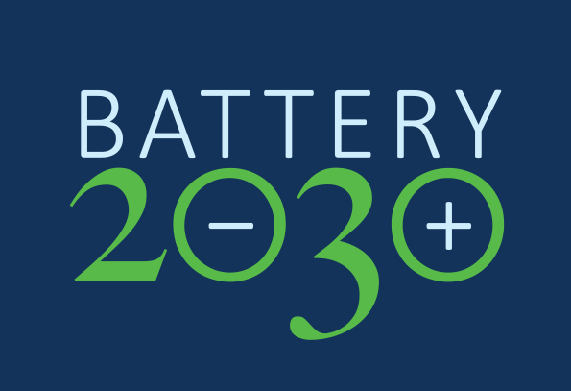
Figure 1. This is a figure.

REFERENCES
[1] Reference #1
[2] Reference #2
…

