PROMOTIONAL MATERIAL

Website:
https://meetbattery2030.eu

Social Media accounts:
Linkedin: https://www.linkedin.com/company/battery2030/
Twitter: @2030Battery

Key dates:

30th March: Abstract submission for the poster session deadline
30th April: Registration deadline
9-10th May: Annual Conference

Banner:

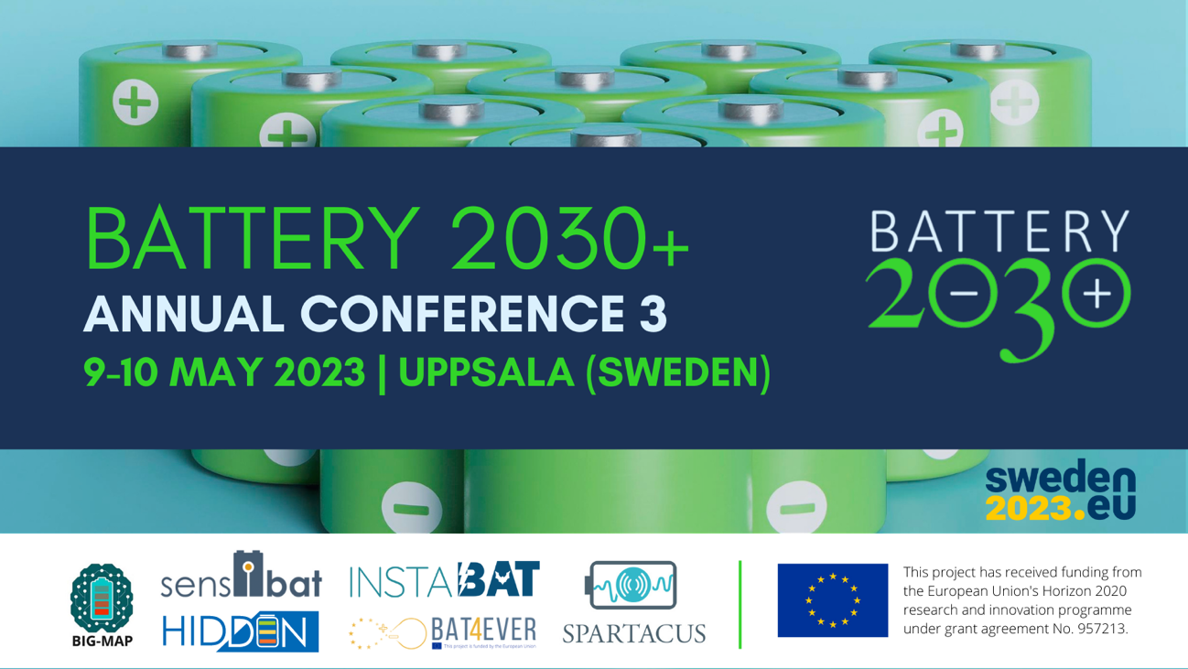

Video:
https://sp.kvk.uu.se/sites/battery2030/AnnualConference2023/Communication%20materials/battery-2030-annual-conference-may-2023-2023-03-03-11_25_38.mp4

Promotional Email:

Join Battery 2030+’s 3rd Annual Conference on May 9-10th, a two-day event full of insightful discussions on battery research!

BATTERY 2030+ is a European large-scale research initiative reinventing the way we invent batteries.

The 3rd Annual Conference will be held physically on May 9-10th in Uppsala, giving you the opportunity to network with key stakeholders of the battery research community and engage in meaningful discussions to empower green innovation in this field!

This Annual Conference will include presentations from industry, a keynote session by Clare Gray from the University of Cambridge, Young scientists’ sessions, poster pitches and poster sessions as well as lots of networking opportunities! In addition, in this Annual Conference we’ll present the new research projects joining the initiative in 2023.
Check the full programme here, and stay tuned!
We hope to see you in Sweden!

